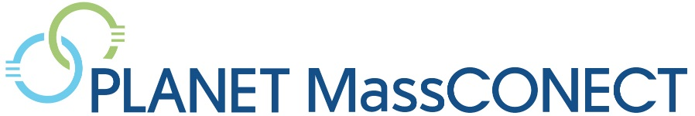
00
MINI-GRANT
OPPORTUNITY

APPLY BY JUNE 30th
Application Information
To apply, please send the attached form to Doris Sempasa at Doris_Sempasa@dfci.harvard.edu by June 30, 2019 to participate in a training in July.
Additional information, including other training opportunities related to evidence-based program planning, is available at: www.planetmassconect.org/training.
Funded by the National Cancer Institute (U54CA156732, PIs: Colon-Carmona, Macoska, Viswanath, Abel).

Calling all Community Health Leaders!
Would you like to adapt and deliver an evidence-based program for biobanking education?

Why does biobanking matter for health/cancer equity?
A biobank is a “library” that stores and manages biological samples (such as blood) for use in research. These samples are often linked to information about the background or behaviors of the person who donated them, though the individual’s name is not shared. Researchers can then take these samples and create new kinds of screening and treatment therapies. Sometimes this is called “precision medicine.” The key for communities that experience cancer disparities is that the biobank/library needs to include people from a wide range of racial and ethnic backgrounds to increase the chance that the treatments and screening tools developed will serve people from those communities.

What does the grant include?
- $1,750 to deliver an evidence-based biobanking education program in your community to an audience of at least 10 people within 3 months of the training
- A 3-hour training on evidence-based health promotion and creating a biobanking outreach program.
- Technical support from our team to plan your event and other health promotion activities.
Who We Are
The U54 Outreach Core is a partnership of community and faith leaders from Greater Boston and Greater Lawrence, and researchers and staff from the University of Massachusetts, Boston, and Dana-Farber / Harvard Cancer Center. We have been collaborating with partners for over a decade to help local organizations make the most of their health programs.
Questions? Contact
Doris Sempasa (617. 632.5252,
Doris_Sempasa@dfci.harvard.edu) OR Carmenza Bruff (617.785.0314, Carmenza_Bruff@dfci.harvard.edu)

Application
Project Organizer / Primary Contact

1. Name: ___________________________________________ Date: ____________________
2. Phone: _____________________________________________________________________
3. Email: _____________________________________________________________________
4. Position/Title: _______________________________________________________________
Organization Information

5. Organization Name: ___________________________________________________________
6. Address: ____________________________________________________________________
7. Population/Community Served: _________________________________________________
8. Organization Type (please check one)

- Community-based Organization
- Community Health Center
- Faith-based Organization
- Other (please specify): ______________

9. Are you applying as a team? (Please note that this is not required.) Yes No
9a. If yes, how many participants are in your group? __________________________________
10. Please describe your organization’s experience delivering health programs.
____________________________________________________________________________________________________________________________________________________________
11. Does your organization have experience delivering evidence-based health programs?
Yes No Not sure
12. Has your organization delivered education on biobanking?
Yes No Not sure
Authorizing Signature – Confirming: 1) leadership support for staff to attend the training, 2) a commitment to deliver the program within three months of the training, and 3) commitment to provide a one-page summary of the event to the U54 team.

Organization Lead Name: ________________________________ Date: _________________
Signature: _____________________________________________________________________

